Meta Description:
Branding goes far beyond logos and color schemes. Read this guide to understand branding types, components, and impact on brand differentiation.
Branding Agency in Dubai | 1600
branding agency Dubai | 1600 | 39
creative agency dubai | 590 | 26
best branding agency in Dubai | 480 | 18
branding solutions for small business | 90 | 15

An Ultimate Guide on Branding: Definition, Types, Components and Much More

When it comes to competing in today’s complex and diverse business world, a powerful brand asset is compulsory for a company. Branding is the basis of business identity and the lack of it reduces the chances of a company’s survival on the market. For a startup in Dubai or any firm that needs a brand overhaul, this information is crucial to help in the branding process. This guide shall provide an understanding of the types of branding, components, and approaches when branding with Three Angle Marketing.

What is Branding?
Branding is more than just designing a company symbol of logo and color patterns. Fundamentally, it is the connection that your business makes with your customers. It has often been described more as your company’s unique persona. In simple words, branding means the emotions people have when your company name is mentioned.

A Quick History Lesson
Branding isn’t new. The Ancient farmers used branding as a tool to show ownership of their animals. In the medieval period, guilds employed such a symbol to vouch for the authenticity of their products. Moving to the contemporary world, branding is active on social networks, websites, and now even artificial intelligent tools applied to customer relationships.

The Psychology Behind Branding
What is the reason why consumers are willing to pay more for a cup of coffee from Starbucks than a regular black coffee? It’s all about perception. Strong brands appeal to pathos, the emotions of trust and happiness, as well as hearkening back to childhood. For instance, Apple’s branding is not just a product of technology but of innovation, creativity, and simplicity.

Branding is a Marathon, Not a Sprint
The development of a brand is described as a continuous process rather than a one-time activity. It is a long-term process of adaptation and growth in regard to the audience. Consistency and adaptability are crucial in the development of a brand.

Branding vs. Marketing: What’s the Difference?
You see, brand is the story that belongs to a certain company while marketing is the method of sharing that story to the public and storytellers are the people responsible for that. Some people do not understand the difference between branding and marketing, in reality, both are two sides of the same coin:
Branding = Who you are?
- Refers to the characteristics that set a brand apart from the rest of the community. It may be brand identity, values, and reputation.
- For instance, Nike’s campaign “Just Do It” has been associated with the empowerment of the spirit of individuals.
Marketing = How do you promote yourself?
- Promotions through marketing channels such as Search Engine Optimization and Social Media Marketing.
- Example: Nike’s seasonal campaigns for new sneakers.

How Branding Boosts Marketing?

A solid brand makes marketing easier. It increases the familiarity of the customers, and by seeing the advertisements they automatically consider them as genuine.

Case Study: Coca-Cola
Coca-Cola’s branding revolves around happiness and sharing. Their holiday ads (for example Santa ads) make more sense because they resonate very well among their customers. One thing that remains the same during every Coca-Cola ad is their branding while on the other hand, their marketing strategies constantly evolve.

Components of Branding:
If you want to build a memorable brand for your company, here are some components of branding you need to focus on:
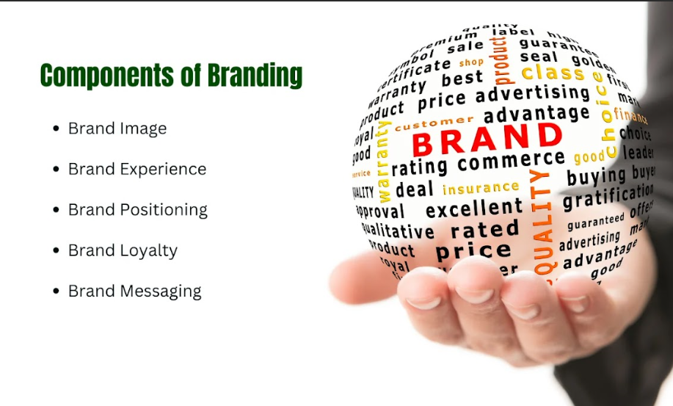

Brand Image
Brand image refers to the outstanding features of the brand such as the brand name, hues, fonts, and general appearance. A strong brand image must accompany one another to ensure that the message created on one media platform is consistent on the other.

Brand Positioning
Brand positioning describes the positioning strategy that a brand intends to use when promoting its brands to the public. It is about understanding what makes you stand out from the competitors and getting your unique selling proposition (USP).

Brand Messaging
Brand messaging is the way you express your brand and what exactly you offer to your customers. It is very important for the formation of a cohesive plot that would be more effective for your target market.

Brand Experience
Brand experience is the overall trajectory of the relationship that customers have with the brand starting from the time they are exposed to it up to the time that they seek another round of service from the company after purchasing a product. Heightened customer awareness increases buyers’ likelihood of visiting the brand ultimately sales are boosted by repeat customers.

Brand Loyalty
Brand loyalty is a culmination of the promises that are made by the brand, and it can be positive or negative depending on the delivery of such promises. Customers continue to use your brand and turn around to refer their friends and families to the same brand ultimately improving organic growth.

Types of Branding Services in Dubai
Branding is not just one simple rigid brand strategy that you can implement in your work environment and yield wonderful results. It is important for different businesses to adopt different strategies in an organization that suits their goals and objectives. Below is the categorization of the main branding services that are available in Dubai:
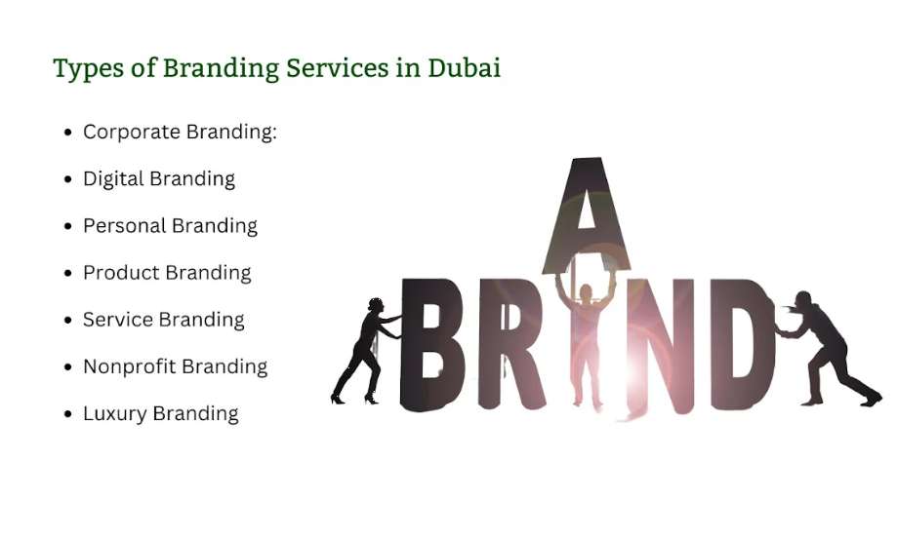

1. Corporate Branding
It is the process of creating a recognizable image for a whole enterprise. It lies in strengthening the company’s position in the eyes of the external and internal public, customers, investors, and employees.
- Importance: Due to increased competition in the market, it becomes important for a corporation to establish itself in the market to attract more investors and other potential partners.
- Key Features: Entity’s description, including its mission and values, its communication, and graphic image.

2. Digital Branding
In today’s hi-tech world, it does matter to be online. Web branding or digital branding relates to establishing ways how to utilize a website, social media, or any other platform to offer a uniform and appealing brand image.
- Relevance: Digital Branding is of paramount importance, particularly in Dubai, where consumer traffic online is high. That’s why strong online brand awareness can prove effective in the long run of the business.
- Areas: Website, SEO, social media, content promotion.

3. Personal Branding
The branding of oneself is critical especially when one is in business. Due to the increased competition in Dubai, a need to invest in a personal brand.
- Relevance: It marks the importance of styling in a city which predisposes people with talents to opportunities that may not be accessible to others.
- Components: Personal branding plan, online presence, connections, and positionality.

4. Product Branding
Product branding is a way to brand selected products through packaging and even labeling and telling their story.
- Relevance: In the context of consumer preferences, the successful branding of a product is rather influential in seller-buyer dynamics.
- Key Learning Points: Packaging features and their kinds, design and label transformation, narration, and selling proposition innovation.

5. Service Branding
It is essential for companies that deal with the provision of services and operate in the fields of hospitality, consulting, or healthcare. It is highly focused on the user and the quality of the service.
- Utility: As a service-based economy in Dubai, the establishment of strong service brands holds great importance due to the pressures of customer satisfaction.
- Key Elements Part: Customer perspective, Service delivery, Brand image, Information/ Communication.

6. Nonprofit Branding
Nonprofit branding is a mission-based communication narrative for nonprofit organizations. Through this nonprofit organizations raise awareness about who they are and what they do.
- Relevance: Nonprofit branding is crucial because it influences giving, volunteering, and advocacy by individuals and communities.
- Areas of Concern: Mission statement, narrative/storytelling, graphics/branding/logo, and donor relations/communications.

7. Luxury Branding
Luxury branding focuses on the high-end market of Dubai to deliver quality and exclusivity through their products & services.
- Relevance: As identified in this blog, the luxury lifestyle is well-established in Dubai. That’s why enhanced luxury branding may benefit from appealing to well-off consumers.
- Key points: Exclusivity, quality, and appealing presentation of the visuals, premium branding, and focus on a customer.

Why Branding Matters for Businesses in Dubai’s Dynamic Market?
Dubai faces a massively diversified cosmopolitan economy and businessmen are free to open their businesses from luxury items to tech-based startups. In such an environment branding is crucial to:

Build Differentiation:
Due to the many companies trying to capture the attention of the customer, brand values enable organizations to stand out.

Earn Trust:
As with all goods and services, trust is the foundation, especially in markets with the type of consumers we are dealing with here. A reputable brand fosters confidence among potential customers.

Increasing Business:
Branding that is consistent and which can be easily related can help in making the customer loyal making them patronize the business more.

Source of Additional Revenue:
As good and well-established brands' products sell at premium rates, the firm should be able to generate more revenue.

How Effective Branding Drives Customer Loyalty, Recognition, and Revenue?
A good branding strategy ensures that the identity of a certain business forum is well established to reach the target audience. Let’s understand how branding affects business operations and how it affects loyalty and recognition:
- One advantage of emotional appeals is that customers begin to be loyal to the brands and defend them.
- A good branding ensures that the existing customers can easily identify with the particular brand and distinguish it from other brands in the market.
- Some product brands can afford the charge higher prices than their rivals due to high brand awareness, ultimately increasing the lifetime customer value and brand revenue.

The Role of Branding Services in Business Success:
The concept of branding services is a critical key that has a significant influence on the general success of various businesses in diverse capacities. Here is how branding services in Dubai play a critical role in the success of your business goals:

Build Trust and Credibility:
Recommendation and reliability have become the most valuable asset in the highly competitive market environment of Dubai. Establishing a good association with consumers allows your business to ‘capture’ your customers' loyalty through strong branding.

Create Customer Loyalty:
Branding is not simply a process or an effort of getting customers but it is much more than that. No one can deny the impact of branding on customer retention. The customer experience created by coherent and meaningful branding makes customers come back from mere purchasers to becoming brand enthusiasts.

Attract Top Talent:
Employer branding stands as one of the major considerations when it comes to the selection of staff in an organization. Employer branding is therefore crucial in providing job seekers with a competitive employer brand in the busy Dubai market to hire well-qualified candidates.

Enhance Marketing ROI:
By introducing cohesive branding into your marketing strategies, the success of your brand in terms of digital presence is guaranteed. This improved presence ultimately increases the return on investment for marketing brands.

Support Business Expansion:
As organizations in Dubai seek to diversify into new markets, branding is the perfect way to do that. Here is how brandings support business expansion:
- Customer Trust and Loyalty
- Differentiation from Competitors
- Product Extension Potential
- Employee Engagement
- Positive Brand Perception
- Market Penetration
- Customer Trust and Loyalty

Increase Perceived Value:
The studies carried above clearly show how branding plays an important role in enhancing perceived value. This enables organizations to charge high prices for goods and services along the value chain and make differential distinctions.

The Impact of Branding Services on Differentiating Businesses from Competitors:
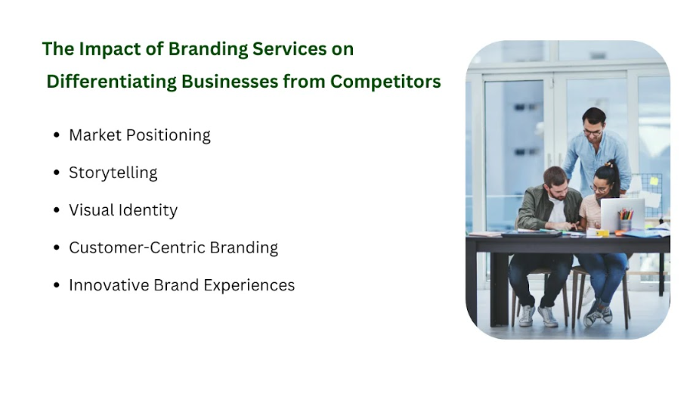
While establishing numerous companies and organizations in the market Dubai, branding has been the light that points to your products. Here are some branding strategies that are necessary for business excellence:

Market Positioning
To be able to achieve a competitive advantage in Dubai, the positioning of the business is very important. It helps you position your business to meet particular needs that customers have in the market through a clear definition of the value proposition of your brand. Here are some of the positioning strategies that your business needs to adopt:
- Quality positioning
- Niche positioning
- Luxury positioning
- Benefit-based positioning
- Competitive positioning
- Price-based positioning

Storytelling:
Storytelling is a powerful technique that enables brands to communicate with consumers in a unique way. As a city of cultural diversities, Dubai offers a perfect place for creating messages that appeal to Middle Eastern and global audiences alike to help distinguish a brand. It is easier for businesses to use the storytelling approach to create an emotional attachment to a brand so that the customers start supporting it. Here are some key elements to craft a compelling storytelling for effective branding:
- Emotional engagement
- Visual storytelling
- Conflict and resolution
- Consistent voice
- Establish a clear brand purpose
- Know your audience

Visual Identity:
An interesting visual image can stand out from the rest and help you capture the audience's attention. Dubai is an architectural city and culturally diverse that requires more creativity and uniqueness displayed in logo designs, colors, and fonts. One major reason for having a unique visual identity is that it makes it easy for the targeted customers to identify your brand.
- Typography
- Color palette
- Graphics
- Graphic elements
- Photography
- Brand familiarity
- Logo

Customer-Centric Branding
You should consider the customers as your top priority in Dubai due to its expanding and diversified population. Research suggests that personalization in branding can enhance customer satisfaction and the interest parties show in a product or a service. This way, you can increase the knowledge of your target audience as well as adjust your brand strategy to make your brand more friendly and attractive to your audience. Here are some customer-centric branding strategies, you can follow for better results:
- Customer journey mapping
- Personalization
- Brand values alignment
- Co-creation
- Customer research and insights

Innovative Brand Experiences:
In Dubai, technology and creativity always go hand in hand. Event activations, as well as AR and VR and immersive campaigns, are some of how brands can engage audiences in an entirely new way. This way, you can not only promote the visibility of your brand but also leave a major impact. Here are some key elements of innovative brand experiences:
- Interactive Digital Platforms
- Social Media Engagement
- Personalized Marketing
- Augmented Reality (AR) and Virtual Reality (VR)
- Experiential Marketing
- Influencer Collaborations
- Gamification

Branding Tips for Small Businesses in Dubai:
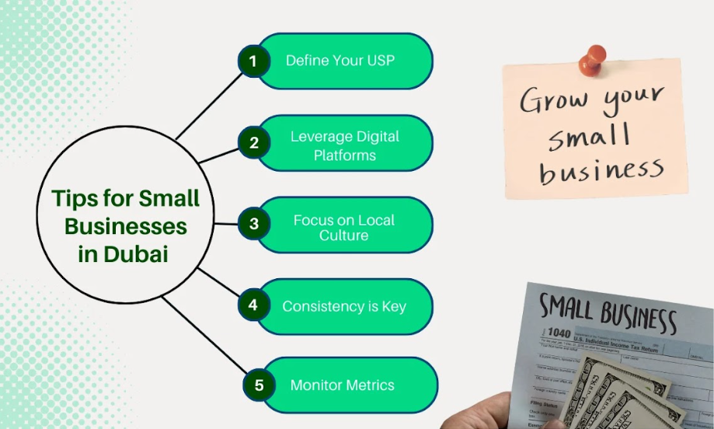
Branding solutions for small businesses are essential in Dubai. Below are some practical tips to use to ensure that you establish the business and make a good reputation in the public:

Define Your USP:
Find out what niche your product or service occupies being compatible with the Dubai situation and the local culture. As for your small business you need to define your USP, whether it is splendid customer relations, new products, or even the company’s business model. All this must be communicated on your internet site to signal what makes your company different from the other companies.

Leverage Digital Platforms
On the Internet, it can be effective to use such channels as Instagram, LinkedIn, or a local SEO promotion. Therefore, a vast majority of the population of Dubai is tech-savvy and populated, so social media and other internet-based resources are the best way to reach your target audience. To be more effective, it is best to follow the strategies relevant to each social networking site for optimized content marketing delivery based on audience welfare and platform availability.

Focus on Local Culture
The traditions and values of the UAE can assist any brand in the branding process by creating a closer connection with the community. To better focus on your local culture, you need to apply cultural references in your branding strategies, either linguistically or iconographically, as well as using events and promotions. This cultural alignment will prove useful in making your brand more appealing and relevant to UAE culture.

Consistency is Key
It's important to ensure that the visuals you use for your brand building align with the messages you disseminate on your popular social and other platforms. Confidentiality also contributes to the reinforcement of your brand so that consumers can easily remember your brand. Make sure the guidelines of your brand are maintained by everyone especially when designing the marketing tools and materials.

Monitor Metrics
Track brand awareness and customer feedback to gauge the effectiveness of your branding strategies. It is important to use analytical tools to track engagement rate, conversion, and customer satisfaction. Through frequent use of these metrics, you can be in a position to make the right decisions and also change your strategies to fit the corresponding result.

How to Choose the Right Branding Agency in Dubai?
Selecting the appropriate branding agency in Dubai is a very strategic decision in the process of branding. Below are the stages of how to find the right agency for your business:

Industry Experience
Make sure to look for a branding agency in Dubai that specializes in your type of business-like retail, technology, or service industry. Industry experience tells us that the agency understands the market in which the company operates and develops the appropriate strategies for the business.

Portfolio Review
This can be achieved by evaluating the agency’s previous completed projects, especially those that have been implemented in Dubai. A broad list is evidence that the agency can provide the service and respond to various brands’ needs.

Customization
Avoid one-size-fits-all solutions. The beauty of the best creative agency in Dubai must be the creation of different strategies that are focused on your company and brand specifically. Customization can therefore guarantee that branding is well implemented and accepted by the target market.

Client Testimonials
Check client testimonials to gauge the agency’s reputation and reliability. Such clients’ feedback can give information on the agency’s expertise and the best way of working together.

Budget Alignment
Make sure pricing for the agency is sensible and reasonable for the amount you have set for your budget. Understanding costs enables you to realize the organizational goals of achieving good return on investment (ROI) and cost control.

The Power of Branding in Dubai:
The competition is deeply rooted in Dubai due to which it requires branding more than ever. A well-crafted brand can:
- Set Your Business Apart: The market usually features a lot of competition therefore it is essential to find a unique selling proposition.
- Create Trust Worthiness: In most cases, customers buy what they know is valid and trustworthy.
- Sell: Gain customers’ usual and continued patronage by delivering pleasant experiences.
- Market Access: Increase your market outlet and explore new business frontiers.

Final Thoughts:

Brand identity is one of the most effective promotional strategies that can turn mere recognition of your company’s existence to a whole new level.
With the knowledge of the branding elements and their types, it is possible to create the proper identity that will be appealing to the target consumers and ensure long-term success. Working with the best branding agency in Dubai like Three Angle Marketing means that the branding needs of your organization will be well understood to serve your desired goals and objectives.
Partner with Three Angle Marketing today for customized branding solutions that propel your business forward. Start your lifelong practice of branding with the right concept that will embody your business and values.

